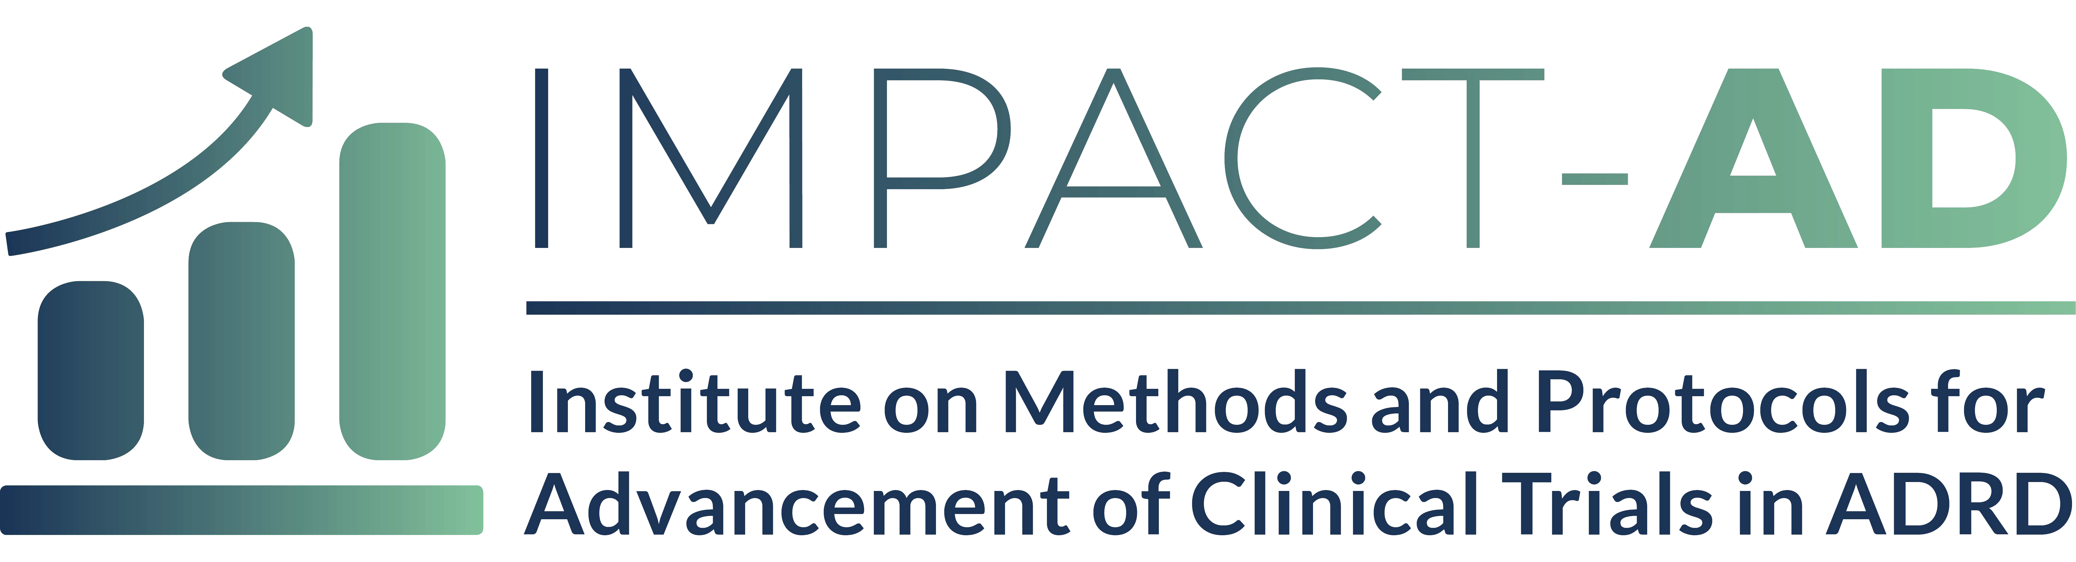
Institutional Letter of Support ( 2 page Max)

Please include a letter of support from a representative of your institution or place of employment that confirms you have the time and ability to attend and actively participate in the IMPACT-AD course, if selected. The letter should also describe your current role in ADRD research and/or clinical trials and how participating in the course will facilitate your career growth.

Letter writers may provide only one letter of support per IMPACT-AD track per year.

