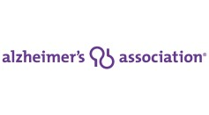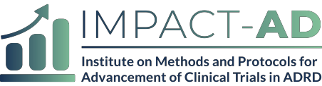

IMPACT-AD Protocol Synopsis: [Study Name]

Study Title
Principal Investigators
Study Design
Study Sponsor
Objectives/Aims
Rationale/Significance
Population
Study Participation Duration
Phase
Description of Intervention
Estimated Time to Complete Enrollment
Key Eligibility Criteria
Primary Outcome Measure
Secondary Outcome Measures
Version 2 – 25 APR 2019
*This synopsis is based on the protocol summary used in the NIH/FDA protocol template.

