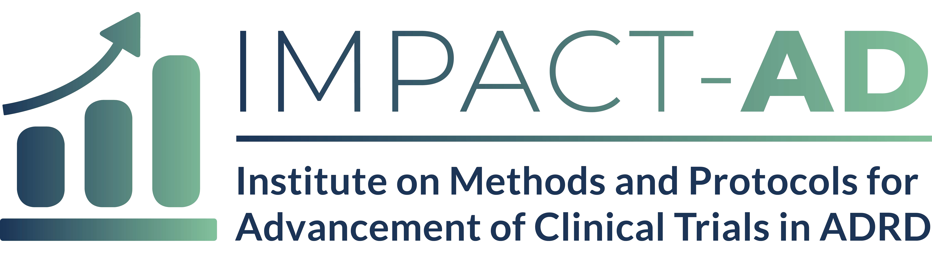

Brief Protocol Synopsis (Fellowship track only) (3 page Max)

Fellowship track participants must submit a brief protocol synopsis using the IMPACT-AD Clinical Study Proposal Synopsis template. These components of the application will undergo peer review for the significance, innovation, and approach taken.

