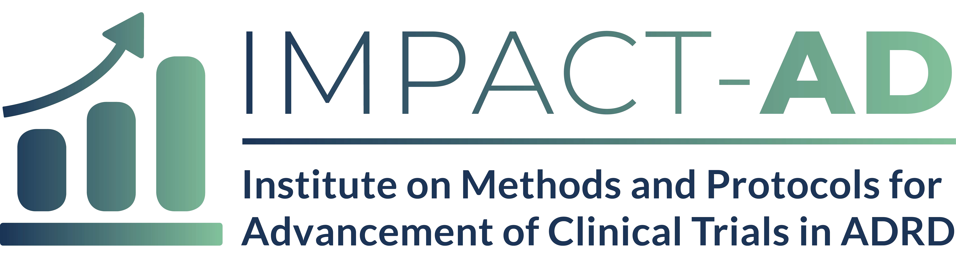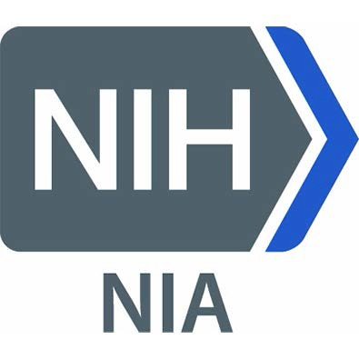

Career Statement Instructions (limited to 2 pages)

The main objective of the IMPACT-AD Course is to grow the pipeline of ADRD trial investigative teams and to provide the tools to interested individuals to enhance their skills and advance their careers in ADRD research.

In this section of your IMPACT-AD application (in no more than 2-pages), please describe the value of this course to your career and the value you would bring to the field of ADRD clinical trials.

- How will this course fit in your current career trajectory?
- What unique perspectives and diversity do you bring to the ADRD clinical trials field? Diversity means many things to the leadership of IMPACT-AD, including but not limited to demographic diversity, diversity of backgrounds and diversity of ideas.

